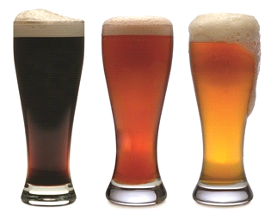The Pacific Café & Bar

“Host Responsibility Policy”
- WE WILL SERVE ALCOHOL RESPONSIBLY OR NOT AT ALL
- WE WILL NOT SERVE INTOXICATED PERSONS
- WE WILL NOT SERVE MINORS
- NO ID NO SERVICE NO EXCEPTIONS
- WE WILL NOT ALLOW INTOXICATED PERSONS TO ENTER OR REMAIN ON THE PREMISES
- WE PROVIDE AND PROMOTE A WIDE RANGE OF NON-ALCOHOLIC BEVERAGES
- WE PROVIDE AND PROMOTE FOOD
- WE PROVIDE FREE DRINKING WATER TO CUSTOMERS
- WE PROVIDE A TELEPHONE AND ENSURE ALL REASONABLE STEPS ARE TAKEN TO ENSURE SAFE TRANSPORT OPTIONS
- WE WILL OPERATE WITHIN THE REQUIREMENTS OF THE SALE AND SUPPLY OF ALCOHOL ACT 2012 AT ALL TIMES
STAFF AT THE
“Pacific Café & Bar”
HOPE YOU ENJOYED YOUR VISIT

HOST RESPONSIBITY POLICY
The Management of “ABC HOTEL” believe that we have the responsibility to provide an environmental that is not only comfortable and welcoming but also where alcohol is served responsibly or not at all.
We provide and actively promote a range of non–alcoholic drinks, tea, coffee and free water at all times.
A good range of food is always available as well. Menus are visible at all times.
It is against the law to serve minors. If we have any doubt as to your age, we will ask for ID. Acceptable forms of proof of age are a current NZ photo driver’s licence, HANZ 18+ card or a current Passport.
Patrons who are judged by the staff as being intoxicated will not be served alcohol, will be asked to leave the premises and encouraged to take advantage of the safe transport options.
We will encourage people to have a designated driver. We will provide an interesting range of Non-alcoholic drinks and free water.
We will make sure all these services are well promoted and will display the necessary signage required under The Sale and Supply of Alcohol Act 2012
We will maintain a training and management policy to give our staff the skills and support required to do their job responsibly.
Please be our guest and take advantage of the services we offer.
“Host Responsibility” makes sure everyone has a good time and leaves in safe shape for the road home. It could save our licence and it could save your life.

We’re responsible hosts.
“ABC Hotel”

